Directions to Pull Report for Career Ready 101

To print reports for grading, follow these easy steps:

1. Select Reports folder at the top of the screen
2. Select Class under Exports
3. Select the Lesson Detail tab
4. Select Download Lesson Detail button on the right
5. Be patient, this takes a minute
6. At the bottom of your screen you should see a gold bar that looks like this:

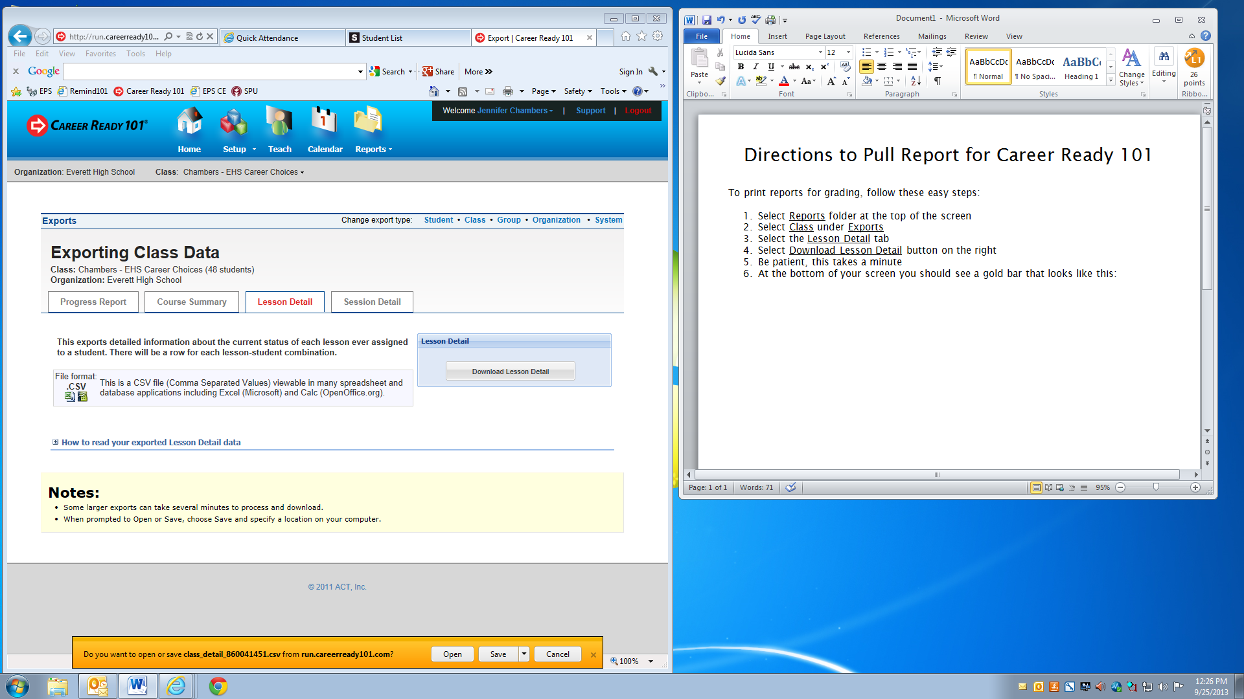

1. Select the Open button
2. Now save this file as **Career Choices Grades 9_25_13.xls** in a folder in your My Documents in case you need to refer back
3. Next we need to delete columns that are not needed. To do this, you will select the column Letter D, hold down the control key and select E, F and G. Next right click on one of them and select delete.
4. Next, select column letter and click and drag all the way across to GY column and right click and delete.
5. Next, scroll back to 1A
6. Expand the columns by double clicking on the line between the column letters
7. Next, highlight all of the boxes with information, by clicking in 1A and dragging it down to the last right row of information in the F column. While the section is highlighted, go to the tool that looks like the symbol below. (This will add gridlines to your selected section)

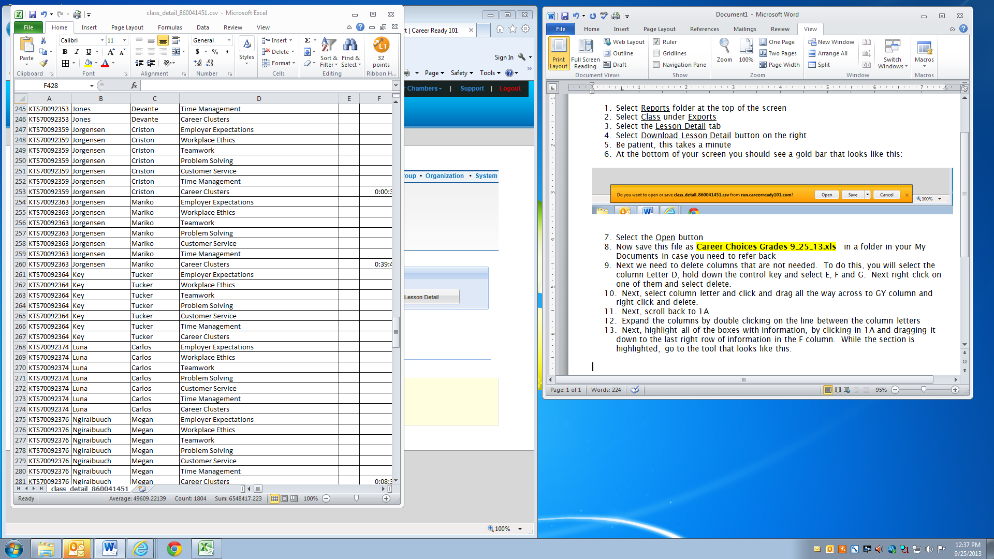

1. You now want to sort students alphabetically by last name for ease of inputting grades. To do this you first need to highlight the entire section. Then you want to select the Sort & filter button. It looks like this:

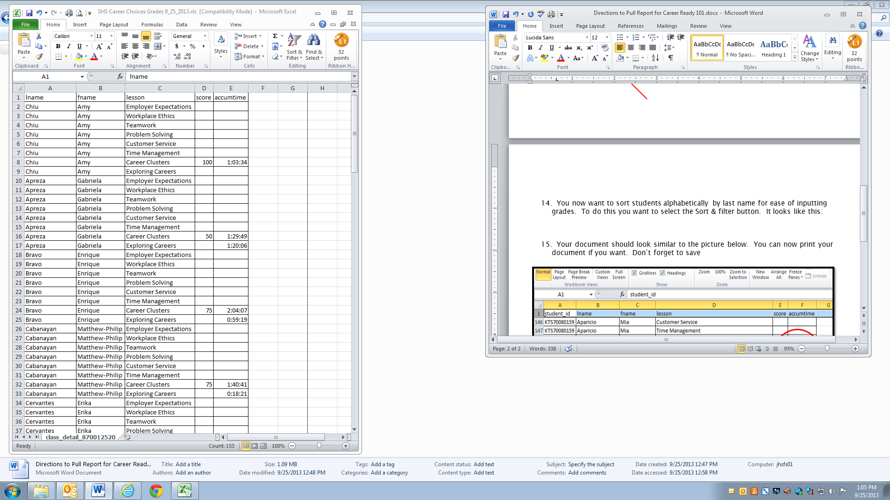

1. You want to select Custom Sort from the drop down list and Sort box will appear. You want to select Column A from the drop down menu in the Sort by window and select ok. See below:

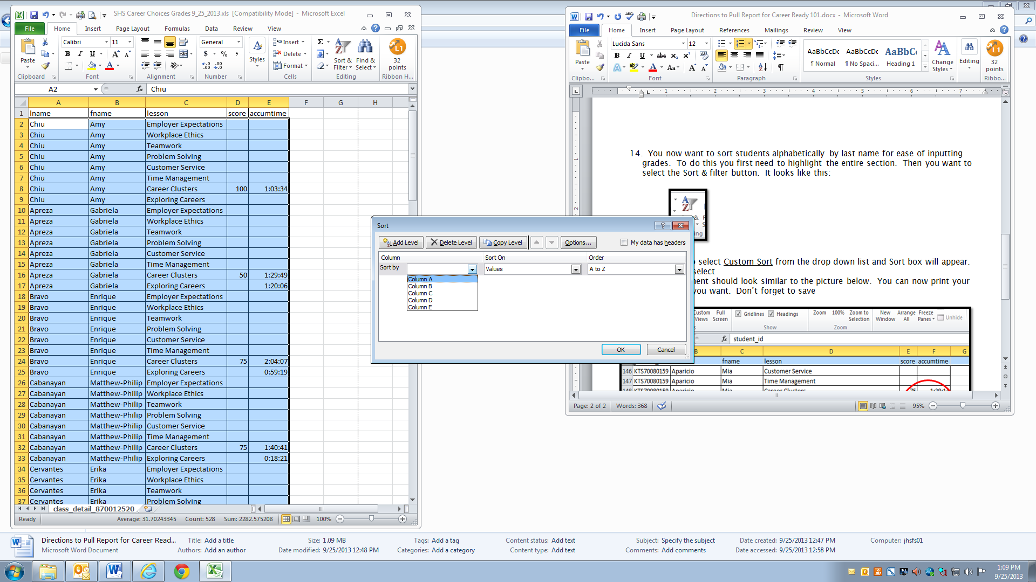

1. Your document should look similar to the picture below. You can now print your document if you want. Don’t forget to save

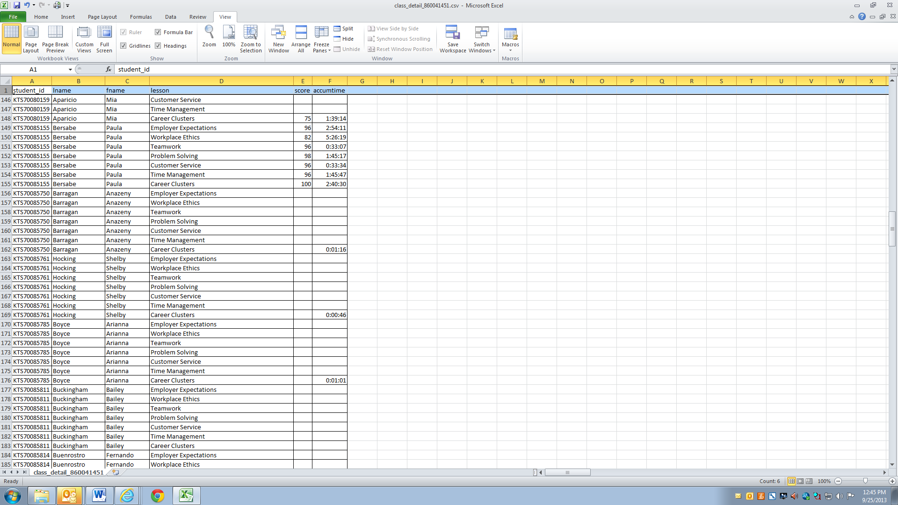

1. Above shows the student has completed all 7 Units of study for the course. It also shows how much time has been spent on each Unit in the last column. This is a great talking point if the student is not passing on at least the second try.